Report:
MLSP Assignment 5
Q3:
part A: Apply PCA to 25 dimensions, and train a DNN with dimensions (25, 256, 256, 10) with softmax non-linearity and two hidden layers to classify the 10 handwritten digits.

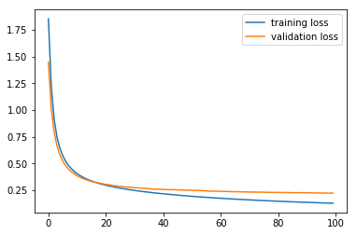
Plot:

We can see, after 40epochs, model is overfitting.
Parameters used: Adam Optimizer(learning rate=0.0001,
decay_rate of learning rate =0.0001)
Test Accuiracy of model at 50 epochs = 91.67%

part B: Apply LDA on the PCA reduced images to 9 dimensions, and train a DNN with dimensions (9, 256, 256, 10) with same output non-linearity for digit classification.
Plot:
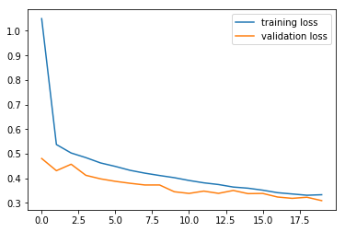

This is the plot for 20 iteration.
Test Accuracy = 89.93%

part C : Gaussian RBM:

Loss plot for this model:
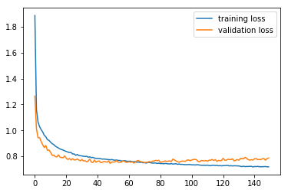

Accuracy = 74.84%
RBM training requires a lot of time. Still it is not giving as good result as without rbm, its because of dimensionality reduction when using rbm.

part D : Autoencoder
plot for autoencoder training loss:
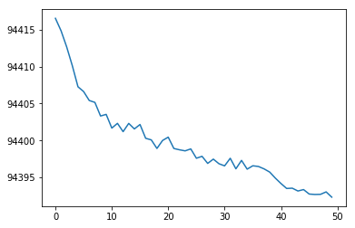

training plot of encdoded data after output of encoder:

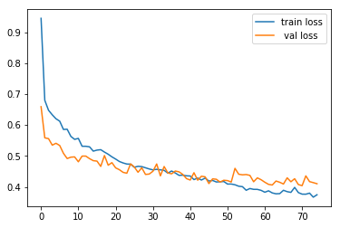

Test Accuracy = 86.17%

